SCHOOL GROUP RESERVATION FORM

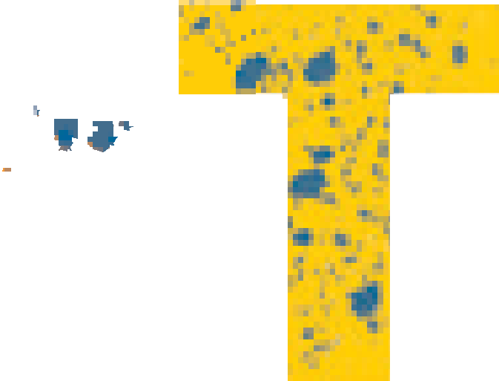

|  |  |  |  |  |  |  |  |  |
| --- | --- | --- | --- | --- | --- | --- | --- | --- |
| **Campus visit date (tick appropriate box)** | | | | | | | | |
| Monday, 2 September |  | Tuesday, 3 September | | |  | Wednesday, 4 September | |  |
| Name & Surname |  | | | | | | | |
| School |  | | | | | | | |
| Cell |  | | | | | | | |
| Email |  | | | | | | | |
| Number of learners |  | | | | | | | |
| Number of facilitators |  | | | | | | | |
| Car/kombi/bus |  | | | | | | | |
| Grade |  | | | | | | | |
| Expected arrival time  (Festival times: 9:00 – 16:00 daily) |  | | | | | | | |
| Expected departure time |  | | | | | | | |
| **Please indicate fields of interest** | | | | | | | | |
| Commercial Photography | | |  | Jewellery Design & Manufacture | | |  | |
| Dance | | |  | Motion Picture Production | | |  | |
| Fashion Design & Technology | | |  | Music *(Jazz & Opera)* | | |  | |
| Fine & Studio Arts  *(Painting, Sculpture, Glass, Surface Design, Ceramics, Printmaking)* | | |  | Performing Arts  *(Theatre Arts & Design:*  *Technical Theatre & Design)* | | |  | |
| Integrated Communication Design *(Graphic Design/Multimedia/Motion Design/Web Design)* | | |  | Performing Arts  *(Theatre Arts & Design:*  *Theatre Arts & Performance)* | | |  | |
| Interior Design | | |  |  | | |  | |

**SCHOOL GROUPS**

Groups are requested to split into smaller groups of 15 learners and must always be accompanied by a teacher/facilitator.

**IMPORTANT NOTICES**

Please note, for official school reservations, no tickets are required.

A confirmation email with more detailed information will be sent to secure your booking and confirm parking arrangements.

Where applicable, an additional fee might be charged for master classes/workshops/some performances (More information will follow shortly).

Learners who want to participate in physical activities should dress appropriately, e.g., sneakers etc.

Participants must be medically fit to participate in physical activities, and schools will be required to present parents' consent forms for participation.

Bring caps and stay hydrated.

Festival programme is subject to change.

Limited seats/access to venues. First come, first serve. Preference will be given to ticket holders.

Participation in the festival activities is at your own risk.

No cooler bags. Please support the vendors on campus.

**POPI ACT**

Please note that photos and videos taken during the festival may be used for publicity/marketing and/or research purposes. All schools are to acquire permission from parents with regards to this matter. Selfie frames will also be available at various activities for visitors to use and share on their social media.

**INDEMNITY**

The University, its staff, students and facilitators will not be liable for any injuries, damage, or loss of any nature to the visitors or loss of any property or articles placed or left on the premises by the applicant.

Please note some of the productions/artwork/designs/activities might address issues of a sensitive nature, e.g., Gender-Based Violence, and visitors must please use their discretion.

*Travel safely and thank you for your support.*

Faculty of

In partnership

**Arts & Design**